Chan Sui Ki (La Salle) College
ECA Section

ECA Handbook
(Club & Society Operation)

Table of Contents

Section |  |  | Page
 | Structure |  | 3
 | Responsibilities of Committee Members |  | 4
 |  | Chairman | 4
 |  | Vice-chairman | 4
 |  | Treasurer | 4
 |  | Secretary | 5
 |  | General Committee Members | 5
 | Committee Meeting |  | 6
 | Financial Management |  | 8
 | Principles and Procedures of Operation |  | 9
 | Designing Activities |  | 10
 | Club Report |  | 12
 | Appendix 1 - A list of considerations in planning an activity |  | 13
 | Appendix 2 - A checklist for organizing an activity |  | 14

Section 1: Structure

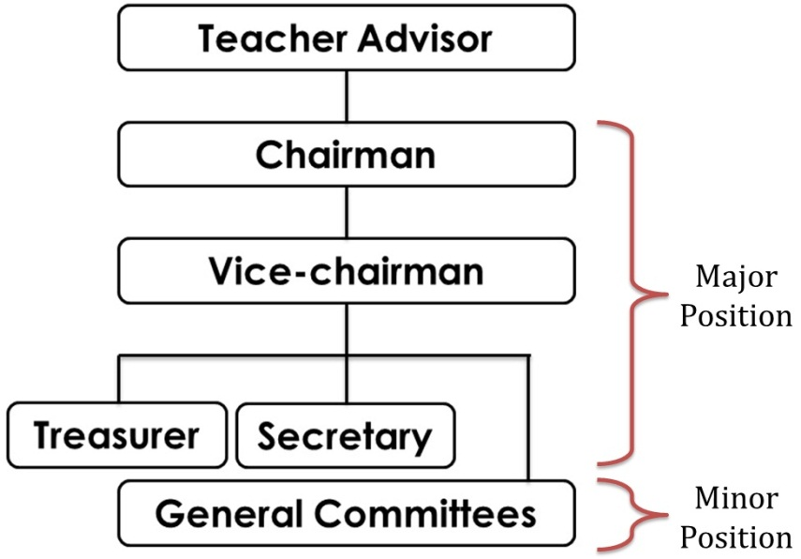
- Committee Members of Clubs and Societies
- There are 6 to 8 committee members in each club and society, including
  - 1 Chairman
  - 1 Vice-chairman
  - 1 Secretary
  - 1 Treasurer
  - 0-4 Other Committee Members
- An organization chart of each club and society is shown on the right.

- Appointing Committee Members
- Under general circumstances, only S3 - S5 students can take up positions in clubs and societies.

- Requirements of Club and Society
- At least 4 committee meetings should be held throughout the school year.
- At least 2 general meetings should be held throughout the school year.
- At least 3 activities and 1 post-examination activity should be held.
- Activities organized by clubs and societies may be open to all students but priority should be given to club members.

Section 2: Responsibilities of Committee Members

- Major Duties of Committee Members
Chairman
- Planning
  - Deciding the club year plan with budgeting with other committee members
- Organising
  - Arranging and promoting club activities of the year, including intra and inter school ones
  - Coordinating committee members, related teachers and ECA Section.
  - Distributing job duties to other committee members with supervision and provide assistance whenever necessary
  - Applying for Club and Society Subsidy from ECA Section, if necessary
- Leading
  - Attending Leadership Training Camp, Chairman Training Course and Chairman Meetings
  - Taking charge of committee meetings and general meetings
  - Representing club or CSK to attend external meetings
  - Awarding merits to outstanding committee members
- Controlling
  - Preparing club reports
  - Evaluating each activity with other committee members and teacher advisor(s)

Vice-chairman
- Assisting Chairman to ensure the smooth operation of the club
- Being the Acting Chairman under special circumstances upon the delegation of teacher advisor(s)
- Arranging promotion of club activities
- Arranging photo-taking duties of club activities and submitting photos to ECA Mistress

Treasurer
- Deciding the budget plan of the year
- Managing all cash flow and keeping all related documents, such as receipts
- Finalizing the financial report
- Managing all non-cash assets of the club and keeping an organized asset record. All cash should be kept by the chief teacher advisor of the club
- Assisting Chairman to handle fund-related issues of the club

Secretary
- Recording and handling minutes of all meetings
- Handling and keeping all club documents in an organized manner
- Assisting Chairman to write club reports
- Handling the application of reserving venue, display panels and other equipment
- Handling all club-related letters and written documents

General Committee Members
- Liaising with other club members and coordinating duties such as attendance in meetings or activities
- Assisting in club activities organization and operation
- Assisting in activity promotion, such as the design and preparation of promotion materials.
- Executing any club-related duties assigned by Chairman and/or his nominees

- Attendance of Committee Meeting
- At least 50% of attendance is required for committee meetings. If 4 committee meetings are held throughout a year, attendance in at least 3 of them is required.

Section 3: Committee Meeting

- Chairing a committee meeting
- Club chairman ought to be present to chair each committee meeting.
- The duties of chairing a committee meeting may include but not limited to
  - Announcing the starting and finishing of the meeting
  - Calling off a meeting if Chairman and Vice-chairman are both absent
  - Guiding the discussion and arranging the order of speech of different committee members
  - Maintaining meeting discipline according to agenda and meeting regulations
- Voting is necessary in making important decisions.
  - All committee members have the right to vote.
  - Chairman is suggested to remain neutral in voting although he has the right to vote.
  - If the votes in favour and against are equal, Chairman should make the decisive vote.

- Recording a meeting
- Club Secretary ought to be present to take notes to record the meeting process.

- Agenda of Meeting
- Agenda should be decided by Chairman and distribute to all committee members, teacher advisor(s) and related people, if any, at least 3 days in advance.
- Chairman ought to enquire attendees if they have any proposal for amending the agenda items at the beginning of the meeting. Chairman can chair the meeting based on the agenda until there is not any disagreement.

- Speech Making
- Chairman ought to maintain the speech order of attendees.
- Attendees should keep their speech brief in order to avoid overtime of meeting.
- Interrupting others’ speech is prohibited. All attendees’ right to speech of speech should be respected.
- Chairman has the right to stop an attendee from speaking in order to maintain the discipline and efficiency of meeting.

- Motion Resolving
- Procedure of Adopting a Motion
  - The motion ought to be put forward by an attendee and then be seconded by another attendee.
  - The motion is called off if no one seconded it.
  - All attendees have equal voting right.
  - Plurality voting system should be used; it means the side with more votes wins. For critical motions, the winning side ought to obtain at least support from two-thirds of all attendees.
- Abstaining from a vote means letting other attendees make the decision.
- All attendees should respect and obey the voting result.

- Preparing minutes
- Secretary is responsible for taking minutes. Chairman should assign one more committee member to carry out the duty in case Secretary is absent from a meeting.
- The format of minutes is defined by ECA Section.
- The essential components of a meeting include the followings.
  - Meeting Information: Date, Time, Venue
  - Names of attendees, observers and absentees
  - Details of discussed items
  - Details of motions and voting results
- Minutes ought to be finalized within 3 weeks after the meeting and be approved by Chairman and presented teacher advisor(s). Approved minutes should be distributed to attendees by Secretary.
- All minutes ought to be attached in club reports.
- All minutes must be written in English. Exception is given to Chinese Language Society, Chinese History Society, Liberal Studies Society and Putonghua Club.

Section 4: Financial Management

- Budgeting
- The financial plan ought to be decided by the club Treasurer and approved by Chairman and teacher advisor(s).
- Financial report ought to be attached to club reports.

- Source of Finance
- Each club member should be charged $10 as membership fee. No membership fee is charged for joining Community Youth Club, Red Cross and Scout.
- Application for Club and Society Subsidy starts in October every year.
  - Late application may also be considered if there is fund available.
  - An application form ought to be submitted to ECA Mistress within 2 weeks after the activity.
  - Chairman is responsible for the submission of forms.
- Application for ECA Support Fund starts in October every year.
  - Late application may also be considered if there is fund available.
  - An application form ought to be submitted to ECA Mistress within 2 weeks after the activity.
  - Teacher advisor is responsible for the submission of forms.

- Cash Management
- All cash should be kept by the Chief Teacher Advisor of a club.
- Teacher advisor(s) should prepay the necessary bills if there is insufficient fund.
- All transaction records, such as receipts, should be kept well by Treasurer.

- Spending Principle
- Avoid budget deficit
- Avoid budget surplus; refund is needed if the surplus exceeds 15%
- Avoid unnecessary and unreasonable spending

Section 5: Principles and Procedures of Operation

Please refer to the document “Guidelines and Procedures for Organising Extra-curricular Activities”.

Section 6: Designing Activities
- Principles of activity design
- All activities should meet the missions of the club.
- All activities should cater for the needs and interests of members.
- Facilities and resources available should be made use of when necessary.
- Participants’ age, physical and mental ability should be considered.
- Participants’ contribution and participation should be encouraged.
- Potential risks of activities should be heeded and a contingency plan should be prepared beforehand.

- Emphasis on skills and qualities in activities
- To tie in with the school major concern of enhancing students’ study skills, it is suggested that at least two study skills (e.g. note taking, remembering, categorization, time management and test preparation) be incorporated in all activities organized.
- To tie in with the school major concern of fostering students’ generic skills, it is suggested that at least generic skills (e.g. leadership, critical thinking, creativity and problem solving skills) be incorporated in all activities organized.
- To develop students’ personal-social competence, students who plan an activity may wish to incorporate qualities such as respect for self and others, concerns for others, willingness to serve, perseverance, commitment and reflection.

- Steps of activity design
- 6W
  - WHY (Objective): purposes of holding the activity
  - WHOM (Target): who are going to join the activity?
  - WHAT (Type): the actual content and style of the activity
  - WHEN (Time): the date and length of time of the activity
  - WHERE (Place): the features of the venue of the activity
  - WHO (Work): division of work among committee members
- 2H
  - HOW (Procedure): how to operate? E.g. programme rundown and recruitment
  - HOW MUCH (Resources): Resources include
- Human resources (e.g. coach, volunteers)
- Equipment (e.g. audio-video system)
- Finance (e.g. charges, subsidies, budgeting)
- I
  - IF……THEN WHAT (Risk Management): estimate the potential risks (e.g. problems of weather, venue and finance) and decide the solutions.
- E
  - EVALUATION (Review): to identify if …
- the activity objective is met;
- participants’ reflection is positive;
- operation is smooth and
- committee members are cooperated well and
- there is room for improvement.

- Activities Promotion
- Promotional channels include but not limited to announcement of morning assembly and club display board.
- All promotional materials should be in English.
- All posters ought to be approved and signed by ECA Mistress before being put up.
Section 7: Club Report and Forms

- Club Reports
- A template for club reports can be downloaded from the ECA website.
- The Mid-year Club Report and Annual Club Report ought to be submitted in January and May respectively.
  - Mid-year Club Report: hardcopy only
  - Annual Club Report: both softcopy (Q:\ Annual Club Report) and hardcopy
  - The Chief Teacher Advisor is responsible for the softcopy submission.
- The club report should be prepared by Chairman and approved by teacher advisor(s) before submitting to the ECA Section. The evaluation form of Teacher Advisor(s) should be part of the club report.
- All activities organised have to be evaluated.
- At least 3 photos of each activity should be attached.
- Clubs and societies demonstrating an outstanding performance will be awarded.

- Forms
- All forms related to the operation of clubs and societies can be downloaded from the ECA website.

Appendix 1: A list of considerations in planning an activity

On behalf of the <name of club> club, we would like to request your permission in organizing an <Internal Function>. The details of function are as follows:

Purpose(s)

The aim(s) for organizing the function is (are) to promote <Purpose(s) of the event>

Target Group

The target group for this event will be <Form of students> students. <Why this group of students>

Time

The event will be held on <date and time>

Venue

The function will be carried out at <venue>

Teacher(s) present

Teacher(s) present is/ are…………and the Teacher-in-Charge of the function is…………

Procedure

It will be carried out in the form of…
<Details of the event>

Evaluation

The Club will evaluate the function by <method of evaluation>

Appendix 2: A checklist for organizing an activity

Name of Function:
Teacher-in-Charge: Teacher(s) present:
Date of Function: Time of Function:
No. of Participants: Form(s) of students:

Item | Date Completed | Remarks
Inform the Teacher advisors of Club & Societies, Functional Groups and Departments
Booking of Venue
Invitation of Guests:
Name of Guests:
Organization:
Contact by phone number:
Contact by letter:
Arrangement of Venue:
Seating arrangement:
Sound system:
OHP:
Video Projectors/ Visualizers:
Others:
Decorations:
Propaganda:
P.A. System:
Poster:
Circular:
Others:
Programme
Printing of Booklets/ Poster:
Rehearsal:
Time:
Person-in-Charge:
Venue:
Financial arrangement:
Letter to Parents/ Student Handbook
Reply from Parents/ Student Handbook Signature
Informing Police/ related institution(s)
Refreshments
Souvenirs/ Flowers
Thank you cards:
Date sent:
Others:

